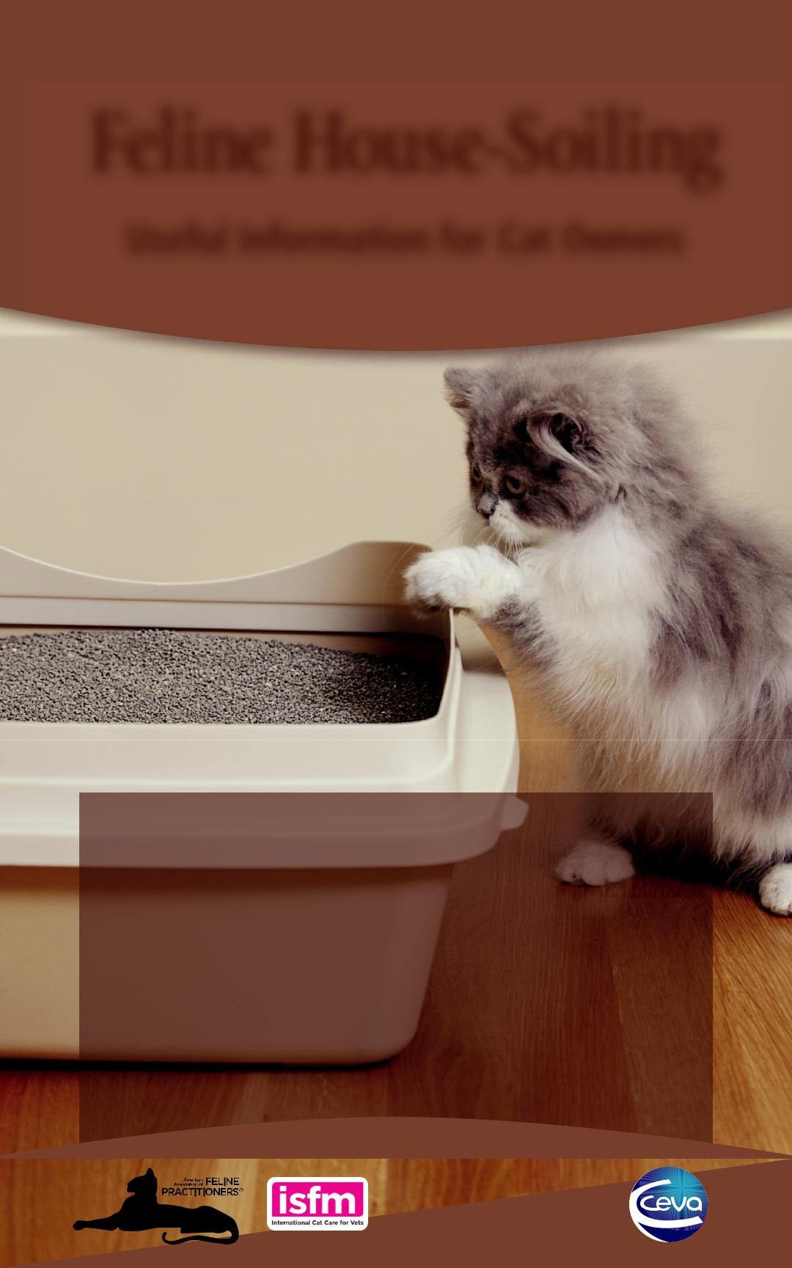**Feline House-Soiling**

**Useful Information for Cat Owners**

**House-soiling is one of the most common reasons why pet owners abandon or relinquish their cats. Unfortunately, these cats frequently end up in shelters where they often are euthanized.**

**House-soiling can be a complex problem to solve, but there are ways to prevent, manage, or resolve feline house-soil-ing behaviors. Your cat does not urinate or defecate outside the box due to spite or anger towards you, but because its specific physical, social, or medical needs are not being met.**

*Sponsored by*

**Feline House-Soiling**

**Useful Information for Cat Owners**

**FOUR BASIC CAUSES OF HOUSE-SOILING**

•***Environmen***Catsbynature***aland***are***Social***veryclean***Fctors***and need adequate unsoiled locations to eliminate, especially in a multi-cat household.

• Some cats may avoid using a litter box located in a high-traffic area or near cat doors or flaps.

• In a multi-cat household, the presence of a more dominant cat near the litter box area may cause a less confident cat to seek out other places for elimination.

• House-soiling may occur if a cat had a negative experience while it was in or near the litter box (e.g. someone administered medications, family members or children trapped a cat in the box for any reason, a dirty litter box, or even being startled by sudden noises from nearby furnaces or other loud appliances).

•***Marking***Urinespraying***Behavior***is a normal part of feline behavior in which a cat marks to leave its scent. Marking behaviors can include scratching, rubbing, urine spraying, and middening (depositing feces).

• Unneutered male cats and most unspayed females will mark as part of their sexual behavior. Spaying and neutering dramatically reduces this behavior.

• Anxiety-related marking occurs in response to a change in the cat’s environment, especially the core area where the cat eats, sleeps, and plays.

• Cats often target items with new or unrecognized smells such as backpacks and shoes.

• Marking behavior that starts at windows and doors usually suggests that the perceived threat is coming from outside the home. Marking in stairways, hallways, doorways, or the center of rooms usually indicates stress or threats from inside the home, such as other pets or new people in the household, active children, or remodeling.

•***Medical***Medical***Cau***issues***esand***can ***Problems***causeacat to exhibit behavior changes such as house-soiling. Your veterinarian will be able to diagnose or rule out any medical conditions that could be a factor in the house-soiling behavior.

• Every cat that starts to house-soil requires a thorough physical examination and urinalysis to check for medical problems such as infections, cystitis, arthritis, kidney problems, diabetes, and other medical issues.

• If your veterinarian believes the house-soiling behavior is caused by a medical reason, he or she may perform additional tests such as a urine culture, abdominal radiographs, abdominal ultrasound, complete blood count, and biochemical profile. Digital rectal exams or fecal testing may be needed for cases of house-soiling with feces.

•***Feline***Feline***Id***idiopathic***opathicCystitis***cystitis (FIC) is a frequent medical cause of house-soiling. Cats suffering from FIC have increased frequency of urination, difficulty and pain when urinating, and can have blood in their urine. This inflammatory condition can increase and decrease in severity over time and is aggravated by stress, changes in diet, and other issues.

The**REATMENT**designand management**ANDMANAGEMENT**ofthelitterbox**OF**are**HOUSE**critical**-**for**SOILING**encouraging acceptable toileting habits. When house-soiling occurs always evaluate the litter box.

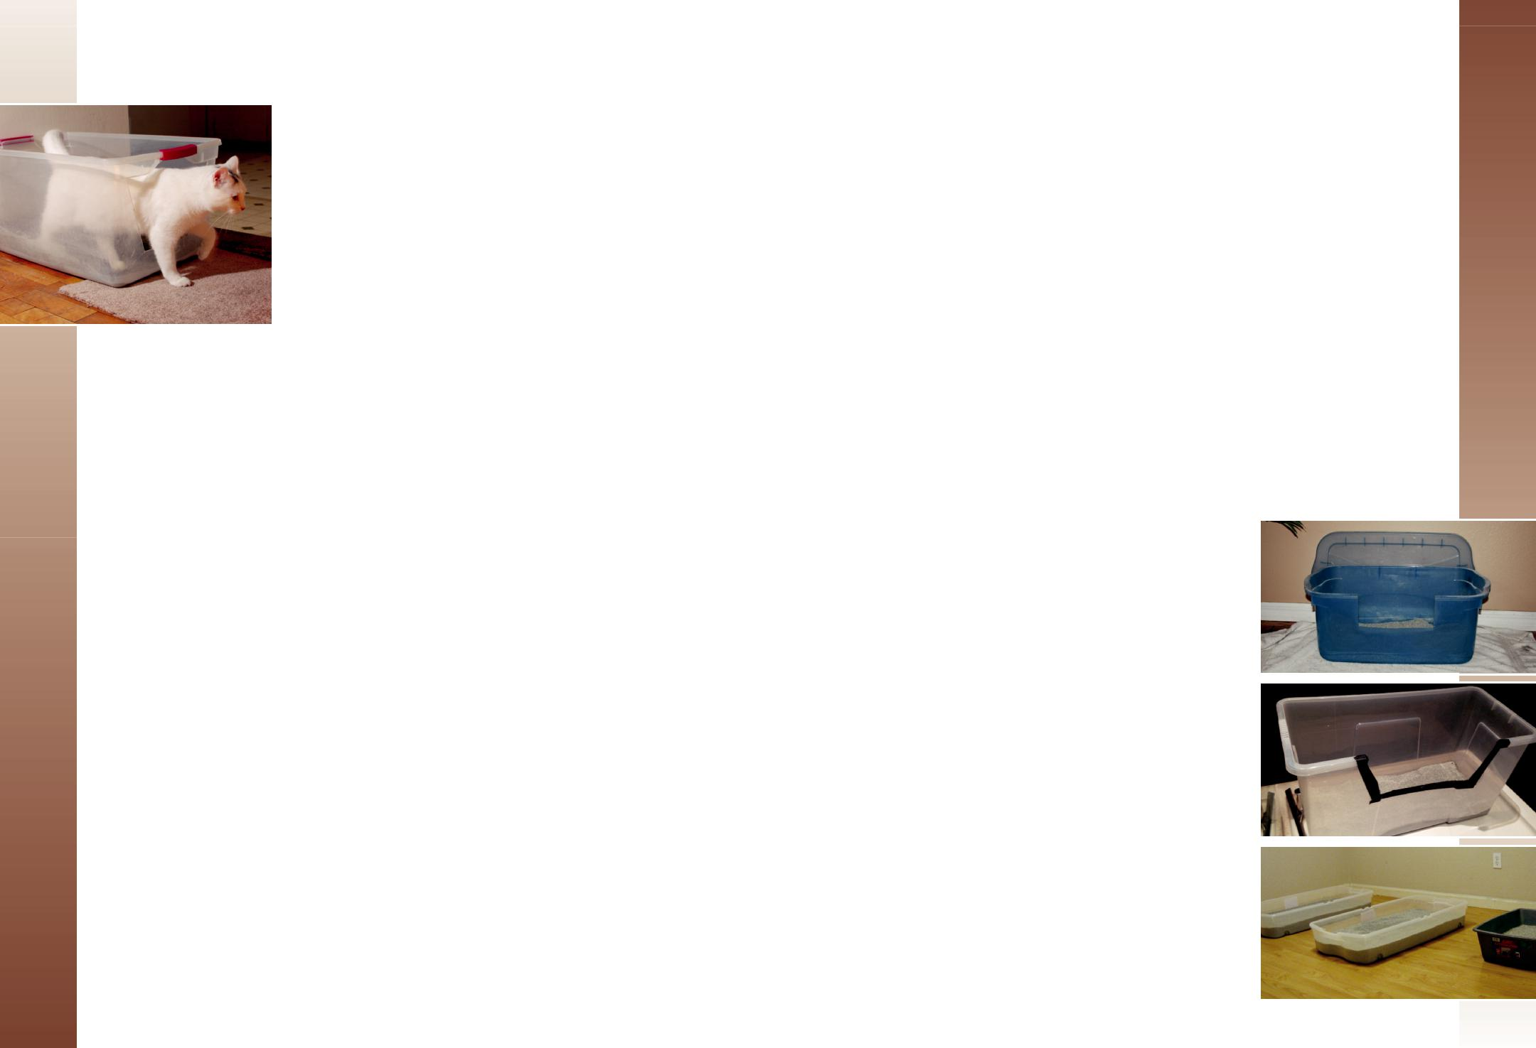

|  |  |  |  |
| --- | --- | --- | --- |
| **Designing the Optimal Litter Box** | |  |  |
| ***Number –*** The general rule of thumb is to have one litter box for each cat, plus one extra | | |  |
| box in multiple locations around your home. Socially affiliated cats, which are two or more | | |  |
| cats that are familiar to each other, share a territory, and exhibit behaviors such as grooming, | | |  |
| playing, or resting together, may be more willing to share litter boxes. Because more than | | |  |
| one social group may occur in a home, providing adequate resources for each group is | | |  |
| important to decrease the chance of adverse behaviors. | |  |  |
| ***Location –*** Take a look at the floor plan of your home and where your litter boxes are located: | | |  |
| • | Avoid placing food and water close to the litter box. |  |  |
| • Cats usually prefer quiet, private places. Avoid busy areas of the home and locations | | |  |
|  | where a cat could be cornered in, blocked off, or unable to flee. Cats can be cornered | |  |
|  | in the litter box so they are unable to flee (e.g. if the box is in a closet or small room | |  |
|  | where another cat can block the exit). If one cat prevents another cat’s access to the | |  |
|  | litter box (e.g. the box is down a hallway or in a room where another cat can block | |  |
|  | entry), it can be very stressful and cause the cat to house-soil because the victim is | |  |
| • | avoiding or cannot get to that location. |  |  |
| Keep the litter boxes apart in different locations because your cat considers boxes close | |  |
| • | to each other one large litter box. |  |  |
| If a cat is toileting away from its box, try placing an additional litter box at the new site | |  |
|  | (temporarily or permanently) to get the cat using a box again. |  |  |
| • In a multi-level home, place a litter box on each level. If you | |  |  |
|  | have an older cat, place a litter box on the level where the |  |  |
|  | cat spends the most time, as it may not be easy for the cat to |  |  |
|  | go up and down stairs each time it needs to use the box. |  |  |
| ***Size –*** In general, bigger is better and many commercial litter | |  |  |
| boxes are too small. Litter boxes should be 1.5 times the | | **A** |  |
| length of the cat from the nose to the base of the tail. Suitable | |  |
|  |  |
| alternatives can include concrete mixing trays or storage | |  |  |
| containers. You can place the lid behind the box to protect the | |  |  |
| wall (Photo A). Older cats need a low entry so you can cut down | |  |  |
| the side but inspect for any sharp edges (Photo B). | |  |  |
| ***Litter –*** If your cat is exhibiting house-soiling behaviors, you | |  |  |
| may need to try different types of litter until the cat indicates its | |  |  |
| preference. For preference evaluation, provide multiple boxes | | **B** |  |
| with different litters and variable litter depths (Photo C). Many | |  |  |
| cats dislike aromatic or dusty litters, litter deodorizers, and box | |  |  |
| liners. Most cats prefer soft unscented clumping litters. | |  |  |
| ***Managing the Litter Box –*** Remove waste at a minimum of | |  |  |
| once per day and add litter as needed. Wash the litter box every | |  |  |
| 1-4 weeks using soap and hot water only. Avoid strong | |  |  |
| chemicals or any ammonia-based products. | | **C** |  |

* Neuter **Marking**orspayyour**Triggers**cattophysiologically eliminate sexually-related marking behavior.
* Restrict the potential threat of other cats; outdoor roaming cats encroaching on the

household can act as triggers. if the resident cat resides indoors only (never goes outside), use motion activated *Tips:*water sprinklers to make the yard unattractive to feline visitors. Laying plastic carpet protectors upside down in front of sliding glass doors creates an uncomfortable surface and may dissuade other cats from sitting close to the house and intimidating your cat.

* Remove or block cat doors that allow roaming cats to enter the household. use microchip- or magnet-operated devices to only allow access to your cat. *Tip:*
* Cleaning urine-marked areas frequently will reduce a cat’s habit of refreshing its scent on the marking site. Use a black light (UV) to find soiled areas. Clean affected areas with a good quality urine odor and stain remover according to the type of surface that the cat has soiled. Test products on an inconspicuous area first and clean a sufficiently large area to remove the odor, which may be up to three times the size of the soiled area. Avoid using ammonia-based cleaners, which smell like urine to a cat.**Remove**

**Additional**•Ensurethat**Consider**allyourcat’s**tio**en**s**vironmental needs are being met. For more information, visit: www.catfriendly.com/enrichment or www.icatcare.org/vets/guidelines.

• Never punish your cat for house-soiling. Punishment can lead to fear-related aggression, reduces the bond between cat and human, and encourages urine marking in less obvious areas.

• Consider use of comforting synthetic pheromones. Spray Feliway® on affected areas after cleaning to reduce the likelihood of re-marking. After individualizing toileting areas for the cat's preferences, adding a Feliway® diffuser in the room most frequented by the cat reinforces the cat's feeling of security.

**Feline house-soiling can be a frustrating problem. Resolution requires patience, as it can take some time to determine what is causing these behaviors and may involve making changes to several aspects of a cat’s home environment and care.**

**If you are experiencing house-soiling with your cat, please contact your veterinary practice immediately. The sooner these issues are addressed, the happier everyone will be, including your cat. Working with your veterinarian to identify the causative factors for the house-soiling behavior, and effectively addressing those factors, will dramatically increase the chance of resolving the house-soiling is-sues.**

**By understanding and providing for your cat’s environmental and medical needs, you can help your cat to live a long and happy life.**

**You are an important member of your cat’s healthcare team. You can be instrumental in helping with the success of treatments and improved healthcare.**



We wish to thank Ceva Animal Health for sponsoring this document.



|  |  |  |  |
| --- | --- | --- | --- |
|  | **AAFP AND ISFM** |  |  |
|  | STRATEGIC PARTNERS IN FELINE HEALTH AND WELFARE |  |  |
|  | TOGETHER IMPROVING CATS’ LIVES WORLDWIDE |  |  |
| **www.catvets.com** | © Copyright 2018 AAFP and ISFM. All rights reserved. | **www.icatcare.org** |  |
| **www.catfriendly.com** |  |  |
|  |  |  |